Welcome to your Healing Journey! I am excited to be your guide.

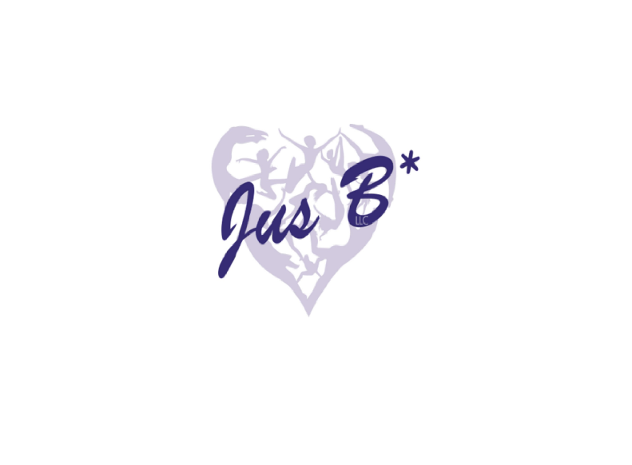
To aid our Mission of serving all clients with dignity and respect through creating a safe, spiritual healing environment that holds you in the highest vibrational arena in support of your healing journey, we must adhere to a few guidelines. Please let me know if you have any questions about these policies or anything else during our journey together.

We will spend time at the beginning and end of each session recapping the energies released and/or awakened, which can occur before, during, and after each session. It is essential for you to set aside any expectations regarding the results; your experiences will most likely be different each time you have a session.

Most issues have developed over time, not usually overnight; therefore, believing that one session will ‘fix’ everything is unrealistic. A series of consistent sessions to experience long-term relief is recommended.

The tones of the singing bowls are generally gentle and safe for everyone. That said, here are some things to keep in mind:

- A gentle reminder that JusB*LLC operates in and through nature. Our work denounces the need for foreign and toxic substances in our bodies and supports pure, natural ingestions. Therefore, anyone under the influence of alcohol or drugs during their session will be turned away and charged the full price for the appointment.
- Don't get too close to the instrument: never put your head inside of a singing bowl or too close to a gong, as it can damage your hearing and shock your central nervous system. Additionally, if you're particularly sensitive, you may not want to lie too close to the bowls, as it can feel intense and overwhelming.
- Listen to your body (and gut): Always listen to your body and your needs, and if something doesn't feel right, please honor that feeling and adjust your position, speak up, or leave if you need to.
- Avoid if pregnant: Listening to singing bowls is generally safe for all points of pregnancy, but we recommend avoiding sound baths that use gongs for the first 120 days of pregnancy. Pregnant people should also lie in a position that is safe for the baby (not lying down flat after the second trimester) during sound healing, and always operate under the guise of your physician.
- Use caution if you have a pacemaker, digital implants, or heart conditions: Those with digital devices can attend sound baths with the permission of their licensed medical practitioner and should not lie within 20 feet of the bowls or gong while the instruments are being played. Digital devices such as pacemakers, epidural pain pumps, and implanted insulin pumps may experience problems coinciding with the operational frequencies emitted from the singing bowls, tuning forks, and other healing instruments.
- Talk to your doctor if you're unsure about anything: if you have any concerns about your physical and emotional safety, you'll want to consult your doctor. Singing bowls and sound healing can be a beautiful and complementary practice alongside physical or psychological therapy.

Client Waiver Form
I acknowledge that all statements, written materials, services, classes, workshops, and consultations offered by JusB*LLC and Kristin Whitcomb are not intended to diagnose, treat, cure, prescribe, or prevent any disease or illness and are not to be considered any form of therapy, counseling, or substitute for licensed medical/healthcare. Always consult a qualified physician or therapist when dealing with physical and/or mental illness or disease.

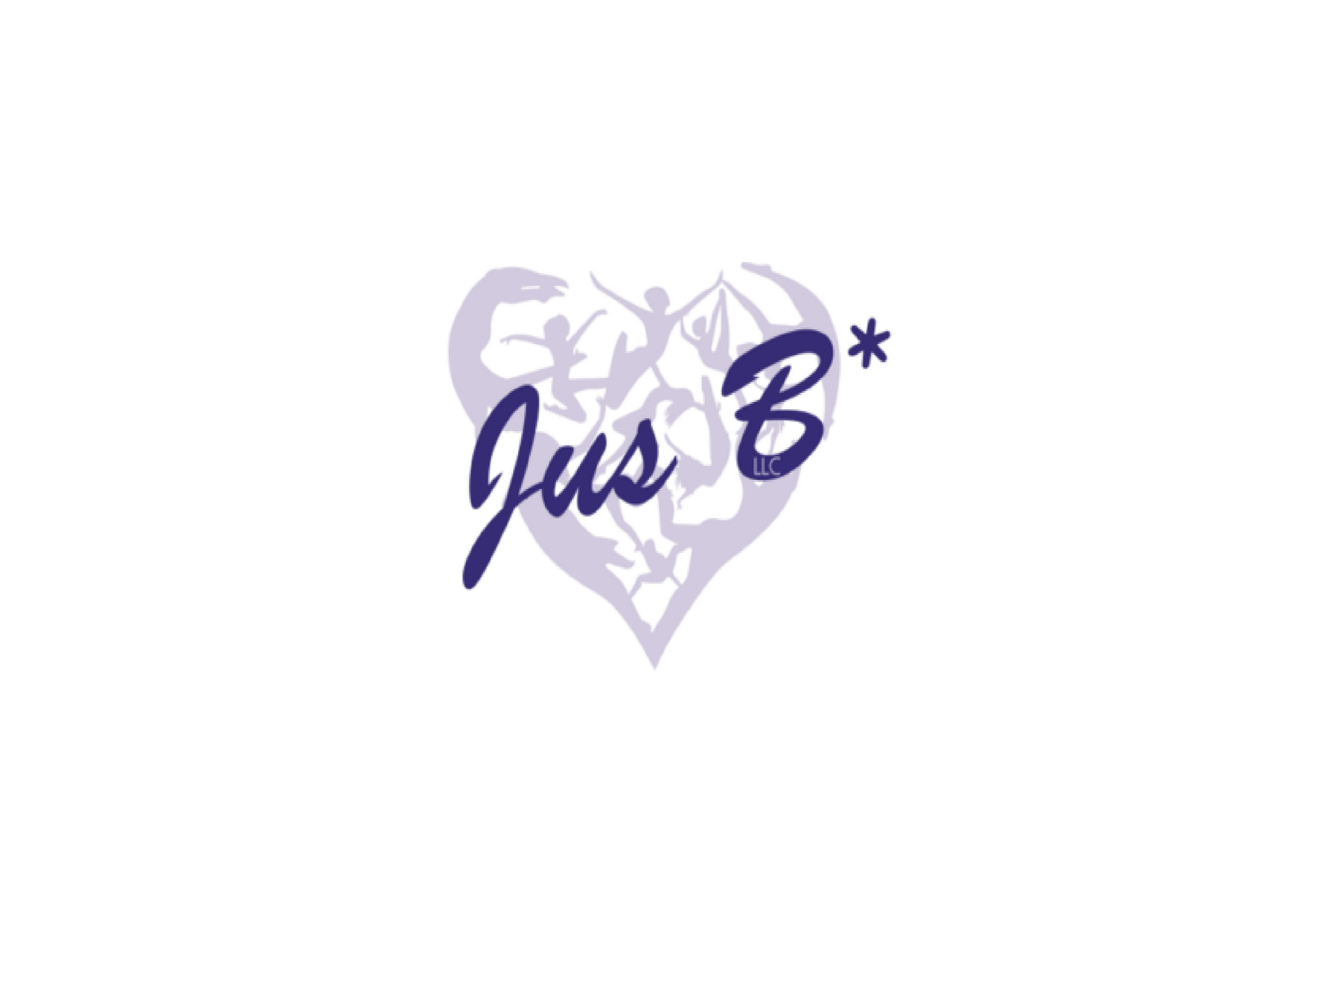
I acknowledge that all services offered by JusB*LLC and Kristin Whitcomb are considered spiritual self-help only and should be used responsibly and at my own risk. JusB*LLC and Kristin Whitcomb shall be held harmless for all statements, written materials, services, classes, workshops, and consultations offered in person or online and shall not be held liable for their use. I understand that all information is of the expressed opinion of Kristin Whitcomb and is founded upon her spiritual philosophies and research. The information is protected and can only be disseminated with written consent from JusB*LLC.

Signature Date: ____________________________________________________ Date: _____________

Printed Name: ______________________________________________________

